4-H Online 2.0 Animal Entry Guide
Small Animal Project
*Note: For 4-H Members 8 and above

Log into 4-H Online

- Use your family email and password co.4honline.com

Click “View”, next to Member’s Name

Locating ‘Animals’
- Desktop, select “Animals” from the left side navigation

- Smart Phone or Tablet, click on the 3 bars in the top left corner
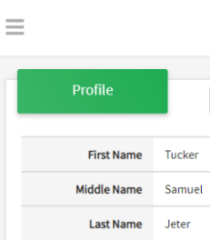
With either option, this will bring up a drop down list to begin adding Animals.

Adding an Animal
- Click "Add an Animal"
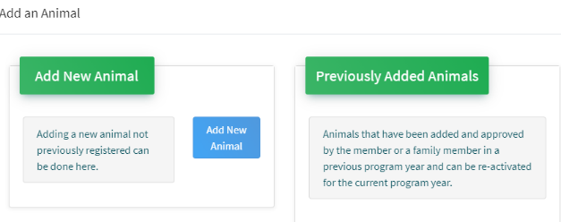Then select “Add New Animal”
- Select Small Pet, from the drop down. REQUIRED: Enter Animal’s name, click “Save”
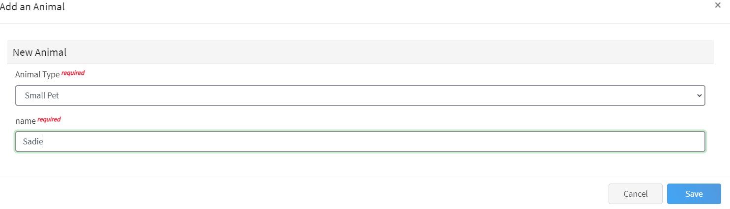
- Next, click “Show Questions”
Animal Entry is open for the current enrollment year. - Is all information complete? Check all county animal entry deadlines.
READ All County instructions for each animal species as county requirements vary.
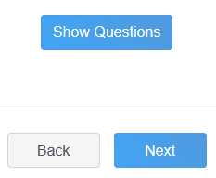
- The animal’s name will be carried over from the previous screen.
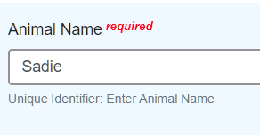
- Enter the animal’s birth date.
- Fill in a description of the dog’s colors and markings.
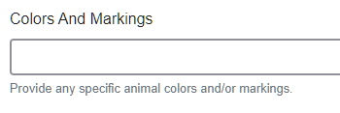
- Enter whether you own or lease the animal.

- Enter purchased or leased date
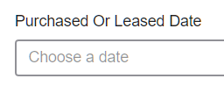
- REQUIRED: Enter the type of Pet (Small Animal) you have
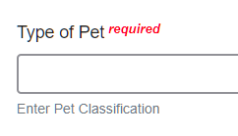
- Click “Next”, continue with the “File Uploads” that are required by your local county extension office. These will vary by county and species. Please follow your county guidelines.
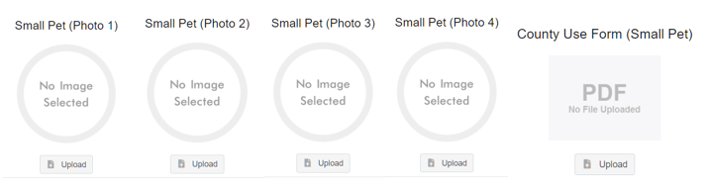
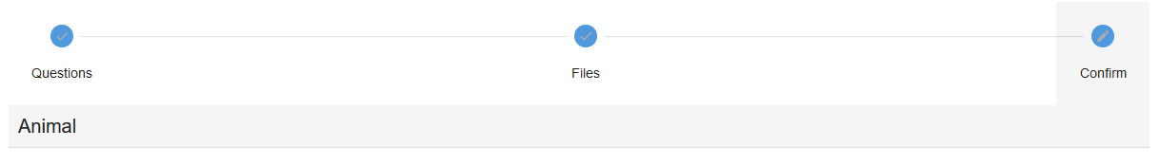
- Confirm all information, click ‘submit’
- County Extention staff, will review all information. If more is needed, members can edit. Once “Approved” by your local county extension office an email will be sent to your family account (example below) A time and date stamp for each animal.
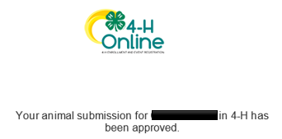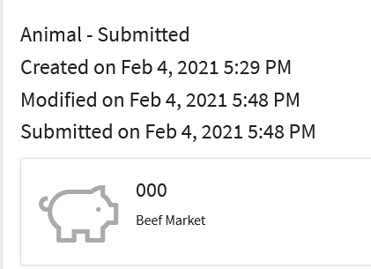
Questions, please contact your local extension staff.

